Table of contents
1. Purpose 1
2. Compare the schedule between Traditional and Agile software development 1
2.1. Traditional software development 1
2.2. Agile software development 2
3. Reporting of planed and actual individual effort log data of K15T1_Team11 week 4 3

Purpose
This document is briefly describing the deferent basic between Traditional methodology and Agile methodology. From that, we consider impacts of two methodologies on the team’s GQM definitions.

Compare the schedule between Traditional and Agile software development
 | Traditional | Agile
Description | Schedule will be upfront and we will consider actual schedule in schedule Plan. | Schedule following user stories, when customer gives more stories, then schedule will longer. They’re proportional.
Measurement | Big plan upfront & earned value. | Burn Down Chart.  Purpose of that is for the team to have visual representation of the amount of work left to complete in the current iteration.

Traditional software development
Goals | Questions | Questions level 2 | Data Collection | Metric Basic | Value
Reduce the product schedule by 10% | How to know current status of progress? | 1. How much time has estimated? | Total days on plan  (dPlan).  Total hours on plan  (hPlan). | 1. % Reduced  = 100 – (dActual * 100 /dPlan) | If % Reduced:  . < 0 : Late  . >= 0 And < 10 : On time  . >= 10 : Reduced
Reduce the product schedule by 10% | How to know current status of progress? | 2. How much time has finished? | Total days on actual  (dActual). | 1. % Reduced  = 100 – (dActual * 100 /dPlan)
Reduce the product schedule by 10% | How to know current status of progress? | 3. How much time has used until now? | Total hours used  (hUsed).  Total hours on plan  (hPlan). | 2. Current position  = hPlan * 90% - hUsed | If Current position:  . < 0 : Late
Reduce the product schedule by 10% | How to know current status of progress? | 4. How many tasks have estimated? | Total tasks on plan  (tPlan). | 3. % Complete  = tFinished / tPlan | If % Complete:  . < 1 : Not complete  . = 1 : Completed
Reduce the product schedule by 10% | How to know current status of progress? | 5. How many tasks have finished? | Total finished tasks  (tFinished). | 3. % Complete  = tFinished / tPlan | If % Complete:  . < 1 : Not complete  . = 1 : Completed
Reduce the product schedule by 10% | How to know effort for each task? | 6. How much rate per task? | Hours (Efforts) on plan(ePlan).  Total hours on plan  (hPlan). | 4. % Per task  = ePlan/hPlan
Reduce the product schedule by 10% | How to know effort for each task? | 7. How much effort need per task? | Metric2. Current position.  Metric4. % Per task | 5. Effort per task  = Current position / % Per task
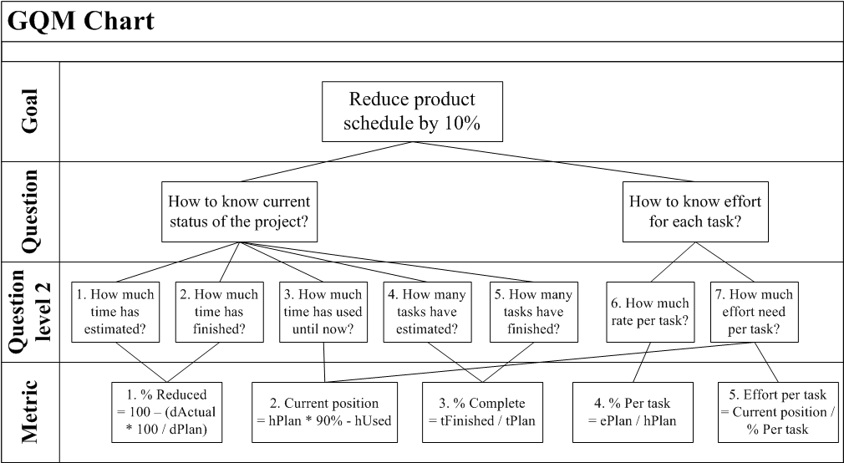

Agile software development
Goals | Questions | Questions level 2 | Data Collection | Metric Basic | Value
Reduce the product schedule by 10% | How to know current status of progress? | 1. How much time has estimated? | Total days on plan  (dPlan).  Total hours on plan  (hPlan). | 1. % Reduced  = 100 – (dActual * 100 /dPlan) | If % Reduced:  . < 0 : Late  . >= 0 And < 10 : On time  . >= 10 : Reduced
Reduce the product schedule by 10% | How to know current status of progress? | 2. How much time has finished? | Total days on actual  (dActual). | 1. % Reduced  = 100 – (dActual * 100 /dPlan)
Reduce the product schedule by 10% | How to know current status of progress? | 3. How much time has used until now? | Total hours used  (hUsed).  Total hours on plan  (hPlan). | 2. Current position  = hPlan * 90% - hUsed | If Current position:  . < 0 : Late
Reduce the product schedule by 10% | How to know effort for each task? | 4. How much rate per task? | Hours (Efforts) on plan(ePlan).  Total hours on plan  (hPlan). | 4. % Per task  = ePlan/hPlan
Reduce the product schedule by 10% | How to know effort for each task? | 5. How much effort need per task? | Metric2. Current position.  Metric4. % Per task | 5. Effort per task  = Current position / % Per task
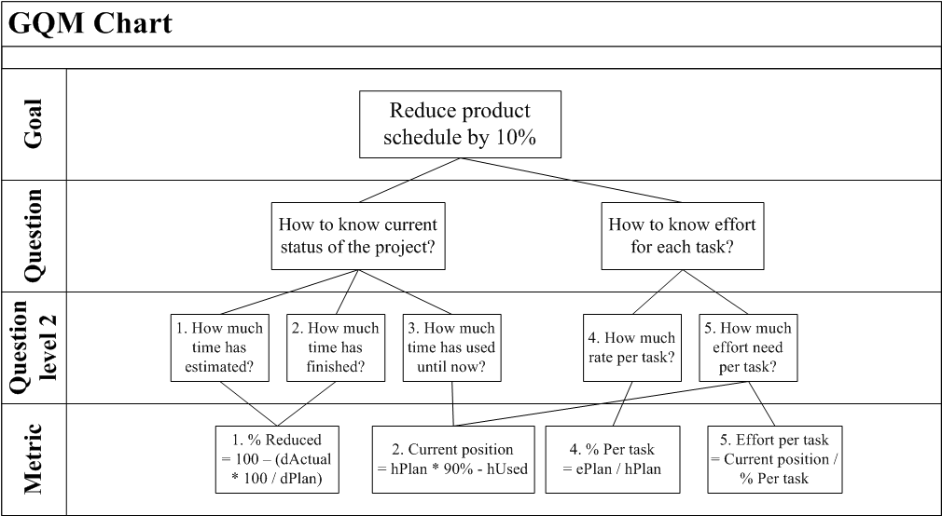

Reporting of planed and actual individual effort log data of K15T1_Team11 week 4
References attachment: “K15T1-Team11-TA4-TeamEffortLog.xls” on Sheet “ Analysis and Conclusion” week 4
